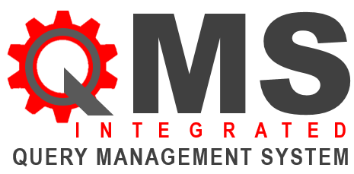

**USABILITY EVALUATION FORMS**



Understanding that the users’ demands on software have changed as nowadays they expect more and more to be able to sit down and use software without spending their time reading manuals.

**Elements Considered in this user evaluation:**

1. The **interaction** between the User and the Software: “How does the system/software talk to you?”
2. The **functionality** of the software to do the job: “Does the system/software function properly and fulfil the objective as intended to”?
3. 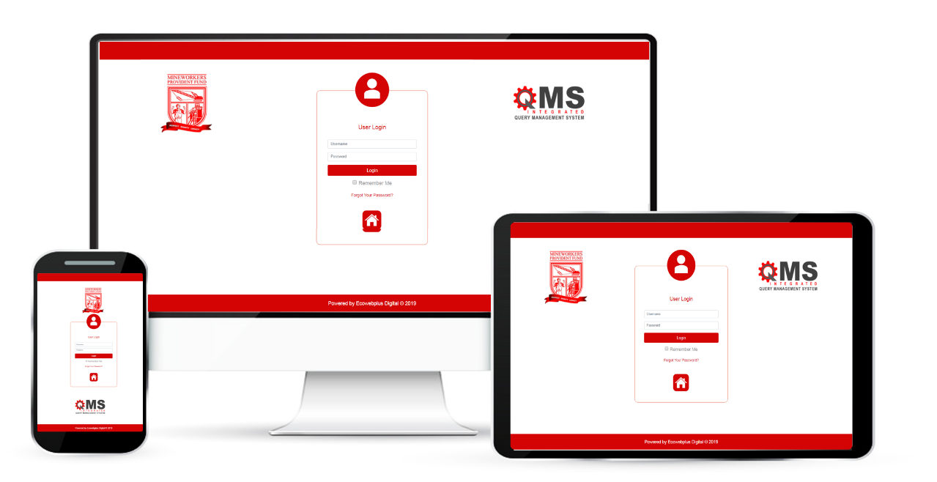The **task fulfilment** by the user through the system/software: “Does the software allow you to complete your expected task /duty and achieve the expected goal, objective and result for which it was built?”



Functionality

Interaction

Task Accomplishment

**MWPF ORGANIZATIONAL ENVIRONMENT**



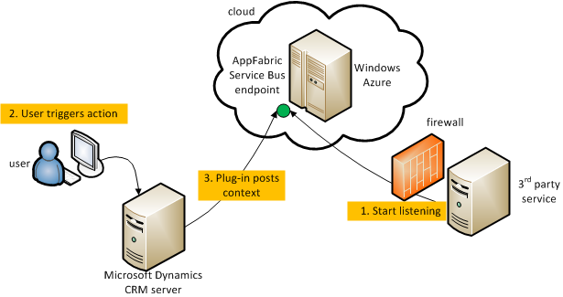

Pragmatically, research has proven that attention to usability has dramatically decreased costs and increased productivity.

Poor user interfaces have resulted in users prematurely abandoning the applications, contributed to disasters, including loss of lives.



|  |  |
| --- | --- |
| QUERY MANAGEMENT SYSTEM (QMS) USABILITY EVALUATION FORMS | |
| Criteria |  |
| Is the level of language that the System offers matches that of MWPF standard? | Yes/No |
| Is it easy to start the System? | Yes/No |
| Is the user interface easy to understand? (For example, is the screen layout clear and easy to interpret?) | Yes/No |
| Is it easy to navigate through the System? | Yes/No |
| Are icons that are used to assist navigation (e.g. back to the homepage, exit) clear and intelligible? | Yes/No |
| Does the user always understand which part, point or section s/he is working on within the System? | Yes/No |
| Does the System include user performance report or self-evaluation? | Yes/No |
| If a user performance report or self-evaluation is used, does it make sense? | Yes/No |
| If a user performance report or self-evaluation is used, does it encourage the user? | Yes/No |
| Is the user offered useful feedback if s/he makes mistake on the system? | Yes/No |
| Can the user seek help while performing task? | Yes/No |
| Does the System branch to help desk, tools or resources? | Yes/No |
| Is query escalation an easy task for the system user? | Yes/No |
| Does the System match with MWPF corporate culture/values? | Yes/No |
| If the System includes pictures/icons, will they be (a) relevant, (b) an aid to ease of use? | Yes/No |
| If the System includes video tutorials, will they be of an adequate assistance? | Yes/No |
| Is the System relevant to your team / skill set / department / area based in accordance with MWPF organizational environment? | Yes/No |
| How easy is it to navigate the QMS? Can you easily get back to the QMS home/landing page? | Yes/No |
| If the QMS contains links to other MWPF platforms, do they work and do they contain what you expected? | Yes/No |
| If the QMS contains links to other MWPF platforms, are they valuable additions or potential distractions? | Yes/No |
| Does the QMS contain an appropriate mix of text, images and video tutorials? | Yes/No |

**Your Comment for improvement:**

Pease take a minute to tell us:

1. What would want to see the QMS do further besides what it does?
2. What would you want the QMS to make your task even easier?

**MWPF QMS Evaluation Form**

|  |
| --- |
| URL of MWPF QMS: 192.168.30.6.85 / 90 |
| Questions to ask |
| Does the QMS system contain what you expected? |
| Who is the QMS aimed at? Is it, for example, aimed at call centres, customer services, helpdesks, government service centres, Complaint Departments/Units, Education and Training institutions, Financial Services, Insurance Companies, Telecommunication & Media, Etc…? |
| When was the QMS created? |
| When was the QMS last updated? |
| Is the QMS easy to access? |
| Is the QMS downloadable? |
| Is the server on which the QMS is located up to the job of delivering its content at any time? For example, does access slow down at peak times? |
| How useful is the QMS for the provision of materials for offline computer-based tasks? |
| How easy is it to turn the QMS contents into useful offline activities? For example, you may wish to download a whole page or selected parts of it for offline use. |
| Do you need plug-ins to access certain features of the QMS, e.g. in order to view certain documents or to play video tutorials? |
| Is there a copyright or “terms of use” message at the QMS, indicating clearly any restrictions on the way in which you may use its content? |

